National Junior College Athletic Association

All-Region XIII
Northner Divsion

This is to certify that
Player’s Name
Name of College

was named to the All-Region XIII Team in Name of Sport

Dated this DATE day of MONTH, YEAR

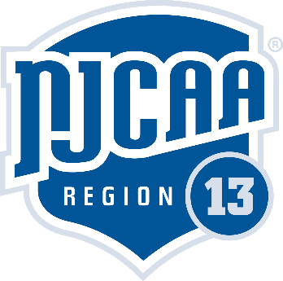
Region XIII Directors: Kurt Kohler & Thai Haggin

